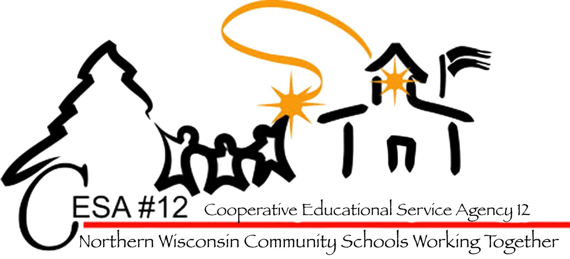

Northern Wisconsin Special Education Conference
July 29-30, 2014
Lakewoods Resort
Cable, WI

Hosted by the
CESA 12
Center for Students with Disabilities
www.cesa12.org

Welcome!

We are so glad that you have chosen to join us for our first summer special education conference! In the spirit of collaboration between regular education and special education, we have developed sessions to apply to all areas of education as we work to improve outcomes for all students. We hope you find the next two days informative and helpful.

Tuesday, July 29, 2014

Day 1 Schedule and Session Descriptions
9:00-10:30
Keynote Presentation: Paula Buege, Wisconsin Family Ties
“Sensory Processing: What Does That Mean?”
Description: Join Paula in gaining a basic understanding of sensory processing and how it impacts youth in everyday life.
Paula Buege has worked with children who have mental health needs and their families for more than fifteen years. Paula is the parent of three children, ages 30, 21 and 20, two of whom have mental health disorders. Paula’s 20 year old son has struggled more significantly with mental illness and autism spectrum disorder, which led Paula to first work in schools with students experiencing challenging behaviors and later become an advocate for other families. She joined Wisconsin Family Ties in early 2009 and in addition to serving families, conducts trainings throughout the state. Paula serves on several state and regional advisory committees where she helps others understand the perspective of youth with mental health disorders and/or challenging behaviors and their families. She is currently the co-chair of the Legislative and Policy Committee of the Wisconsin Council on Mental Health.

10:45-12:00 Breakout Sessions
1. Sensory Processing and Practical Strategies to Promote
Regulation and Reduce Maladaptive Behavior Paula Buege, Wisconsin Family Ties
Description: This breakout session will be a follow-up to the keynote address. Join Paula in learning how to implement practical strategies to promote regulation both for youth and for parents and teachers, thereby reducing maladaptive behavior.
2. LEA Training Gary Ruesch
Description: Placement, personnel costs, BIPs, related services and more: the buck stops with the LEA Rep! This presentation is designed to forewarn, so that LEA Reps can bullet-proof their IEPs and the IEP process, legally speaking. Gary will have plenty of time to answer your questions.
3. Supporting Language and Early Literacy at Home and in Early Childhood Settings Gaye Tylka, Stephanie Lulich, Sue Erickson
Description: The process of becoming a reader and writer begins at birth. Language-rich environments, supportive adult relationships, playful teaching strategies, and repeated opportunities to feel a sense of success and enjoyment with language/literacy experiences are essential. Join this session to learn about effective, developmentally appropriate ways to support the six vital components of language-literacy learning at home and school, and new professional development opportunities available to teachers.

Tuesday Night Cookout
Hugh Davis, Northeast Regional Coordinator, Wisconsin Family Ties
4. Expanded Core for D/HH and VI Jane Charlton and Jennifer Meyer
Description: This presentation will introduce the audience to the Expanded Core Curriculum for students who are deaf/hard of hearing, in its current version. The session will discuss the components of the curriculum and its application in supporting students who are deaf or hard of hearing, including development of IEP goals, articulating the role of the Teacher of the Deaf and Hard of Hearing, and identifying “gaps” in programming that require attention. Participants will interact with the current document and providing feedback on its possible use in Wisconsin.
12:00-1:00 Lunch
1:00-2:15 Breakout Sessions
1. Classroom Management Jen Ledin, CESA 12
Description: Student misbehavior is a frequent interrupter of classroom instruction and a serious roadblock to attaining ambitious academic standards. Research clearly shows that those teachers who implement positive behavioral strategies with quality and consistency gain a strong instructional edge. This session will provide an introduction to some of these positive management strategies.
2. Change Leadership and Results-Driven Accountability: Leading Change in an Era of Accountability Terry Ehiorobo, Assistant Director of SpED Team, WI DPI
Description: How can school superintendents, assistant superintendents of curriculum, special education directors, special education coordinators, special education teachers and regular education teachers find the presence to be a leader of action? This presentation will provide a deep learning of leadership. It will provide the skills to deal with: immunity to change; learned helplessness; improving professional practice and gaining enjoyment with it; and building a strong team to focus on results driven accountability.
3. Putting the Puzzle Pieces Together: Planning for, and Implementing, RtI in Pre-K Settings Gaye Tylka, Early Childhood RtI Statewide Coordinator, CESA 4/DPI-Office of Early Learning
Description: Are standards, accountability, and the demand for high quality in preschool causing a shift away from developmentally appropriate practices to academic learning only? The good news is early childhood pre-K programs can be data-driven, standards-based, AND developmentally appropriate! Participants in this session will examine the individual parts of the puzzle—screening and assessment, standards, curriculum, and teaching strategies—that join together to create daily/weekly experiences to meet the developmental and learning needs of ALL children.
4. Common Core Essential Elements and Instruction: Is There a Connection? Sandy Berndt
Description: Participants will have an opportunity to connect Common Core Essential Elements with the building of curriculum and instruction in ELA and Mathematics. Different approaches for instruction will be discussed with time to explore in small groups.

2:15-2:45 Break

Day 1 Schedule and Session Descriptions

Tuesday, July 29, 2014

Tuesday Night Cookout
Hugh Davis, Northeast Regional Coordinator, Wisconsin Family Ties
2:45-4:00 Breakout Sessions
1. What Kids with Emotional or Behavioral Disorders Really Need Hugh Davis, WI Family Ties
Description: Gain an understanding of the key needs that drive the behavior of children with mental health issues and how those needs should impact our approach in dealing with challenging behavior.

2. Creating Trauma-Sensitive Schools to Improve Learning
Terry Ehiorobo, Assistant Director of SpED Team, WI DPI
Description: Professional educators know that many students face challenges in their personal lives that adversely affect their learning in school. Unfortunately, many children have been traumatized by directly or vicariously experiencing violence, homelessness, loss (or fear of loss) of loved ones, or other kinds of devastating experiences. Dr. Terry Ehiorobo will discuss how school leaders can make our schools more sensitive to those children’s needs by helping them develop resilient skills to prevent secondary or vicarious trauma; learning strategies and techniques to increase resiliency, building staff preparation and promoting buy-in; and developing a team to build awareness of secondary trauma.

3. Introduction to Co-Teaching Jerianne Kvapil-Rosin, Sue Erickson, Stephanie Lulich
Description: Participants will gain an understanding of the key issues of Co-teaching. Co-teaching (or collaborative teaching) is a coordinated instructional practice in which two or more educators simultaneously work with a heterogeneous group of students in a general education classroom. Special education teachers have been the most common to partner with classroom teachers, but successful partnerships have developed with speech therapists, OT/PT, GT, school psychologist, librarians, technology specialists and more. Participants will be led in developing structures and strategies for maximizing student learning.
4. Community-Based Inclusion Programs for Students with Disabilities Age 18-21 Sandy Berndt
Description: Participants will receive information on a process to review the capacity of their school, set up and maintain a Community based program for students with disabilities ages 18-21. Planning tools will be shared and time will be given for questions and answers.

Day 1 Schedule and Session Descriptions

Tuesday, July 29, 2014


Tuesday Night Cookout
Hugh Davis, Northeast Regional Coordinator, Wisconsin Family Ties
Ut pulvinar elit et augue.
Donec ultricies congue nulla. Nulla rhoncus tortor eu risus. Praesent viverra, libero a aliquam pharetra, lacus urna faucibus dui, at vulputate ante augue sit amet justo. Nulla leo est, suscipit in, laoreet accumsan, pulvinar et, massa. Ut interdum orci sed nibh. Fusce quis purus. Quisque cursus nonummy metus. Quisque purus. Proin ultrices lacus et lectus. Nunc nunc elit, hendrerit at, tristique a, rhoncus eget, est. Nullam congue pulvinar nulla. Mauris ornare. Aenean non nulla eget erat varius euismod. Proin diam. Sed odio pede, porttitor eu, faucibus nec, volutpat ac, metus. Donec sit amet arcu in tortor adipiscing fermentum.
Nulla ut metus non purus consequat dignissim. Mauris eget nulla eu arcu aliquet condimentum. Praesent magna libero, cursus at, sodales id, ultricies in, purus. Sed in tortor. Vestibulum quis massa nec augue malesuada nonummy. Morbi in pede sed turpis. Nunc arcu ligula, mattis sed, accumsan et, ultrices nec, enim. Vivamus iaculis cursus nunc. Mauris et mauris in nunc dignissim varius.

Tuesday, July 29, 2014

5:30-7:00 pm

Tuesday Night Cookout and Presentation
Presentation by: Hugh Davis
Executive Director, Wisconsin Family Ties
Parents and school personnel are invited to join us for a cookout dinner and presentation entitled:
“In Our Shoes: Toward an Understanding of Families Raising a Child with Mental Health Needs.”
In this session, participants will gain insight into the challenges faced by families of children with mental health disorders and will learn effective ways to hear and respond to children and families.

Tuesday Night Cookout
Hugh Davis, Northeast Regional Coordinator, Wisconsin Family Ties

Tuesday Night Cookout
Hugh Davis, Northeast Regional Coordinator, Wisconsin Family Ties

Day 2 Schedule and Session Descriptions

Wednesday, July 30, 2014

9:00-10:15 Breakout Sessions
1. Teach Me to Success: Supporting the Social and Emotional Competence of all Young Children Julie Betchkal, Early Childhood PST/Pyramid Model Training Coordinator
Description: The adult outcomes for young children with chronic challenging behavior are alarming. We will briefly
explore why this trend exists, but the majority of our time will be spent considering what we can and should be doing to teach social and emotional competence in the early years. We will review the essential elements and evidence based practices that are necessary to alter the developmental trajectory for young children who are at-risk or exhibiting challenging behavior. Links to resources and materials will be provided, including information on the Wisconsin Pyramid Model Initiative.
2. Universal Design for Special Education Jen Ledin
Description: This session will provide an overview of the concept of Universal Design for Learning and how it can be implemented in regular or special classrooms. We will also see how Universal Design fits in with Assistive Technology for students with disabilities.
3. Fetal Alcohol Brenda Caya
Description: Coming soon!

10:15-10:30 Break
10:30-11:45 Breakout Sessions
1. Programming for EBD Teens John Bemis
Description: Coming soon!

2. Legal Considerations for Discipline of Students with Disabilities Marge Resan, DPI
Description: The Individuals with Disabilities Education Improvement Act (IDEA) 2004 continues to encourage the use of proactive measures to prevent discipline problems. This session discusses the balance struck by IDEA permitting school officials to maintain a safe learning environment for all, while also including protections to prevent the inappropriate exclusion of children with disabilities.

Tuesday Night Cookout
Hugh Davis, Northeast Regional Coordinator, Wisconsin Family Ties

Tuesday Night Cookout
Hugh Davis, Northeast Regional Coordinator, Wisconsin Family Ties

Day 2 Schedule and Session Descriptions

Wednesday, July 30, 2014

3. Access for Technology Mary Maderich
Description: In this session, participants will learn about a variety of online tools for, student organization, reinforcing positive behavior, communications, disabilities and classroom management.
4. Native Families in the Foster Care System Makoons Miller-Tanner
Description: What should teachers know about native children’s relationship with the foster care system? What circumstances lead most often to out-of-home placement for Native children? Who do teachers/school staff involve in the child’s education when they are in foster care? What role can school staff play in encouraging success in children in the foster care system? Join Makoons Miller-Tanner, Indian Child Welfare Social Worker with the Fond Du Lac Band of Ojibwe to explore the answers to these questions.
11:45-12:30 Lunch
12:45-2:00 Breakout Sessions
1. Programming for EBD Teens John Bemis
Description: Coming soon!

2. Understanding the Hidden Disability of Autism Julie Betchkal, Early Childhood PST/Pyramid Model Training Coordinator
Description: Do you ever wonder why students with Autism Spectrum Disorders behave in certain ways? This session will explore the underlying brain differences that are common in Autism Spectrum Disorders and provide Ideas for accommodating for these brain differences. Is neurobiology interesting and applicable to our work in supporting students? Come and find out.
3. Generational Trauma: Healing the Broken Bond Between Families and Schools Desiree Loewe, WSPEI Family Engagement Coordinator, CESA 12
Description: An informed discussion on the generational effects, roots, and causes of trauma on parents and their relationship with their child’s teachers and school, and strategies for educators for working with Native American families walking with generational trauma.
4. Agency 101 Kathy Tuttle, Northern Transition Improvement Grant Coordinator
Description: As students transition from high school to adult life other agencies will be involved in making this a seamless journey. This session will give you an opportunity to meet representatives from many of the agencies you may be working with along with students and families. You will learn important information that will assist you in planning for life after high school for your students. Come with questions, since there will be time to take advantage of this opportunity to connect with other stakeholders in transition planning.
lorem ipsum
93 Perry Street[Street Address]
Error! Bookmark not defined.[City], Error! Bookmark not defined.[State]Error! Bookmark not defined.[Postal Code]
Error! Bookmark not defined.[Web Address]
Notes

